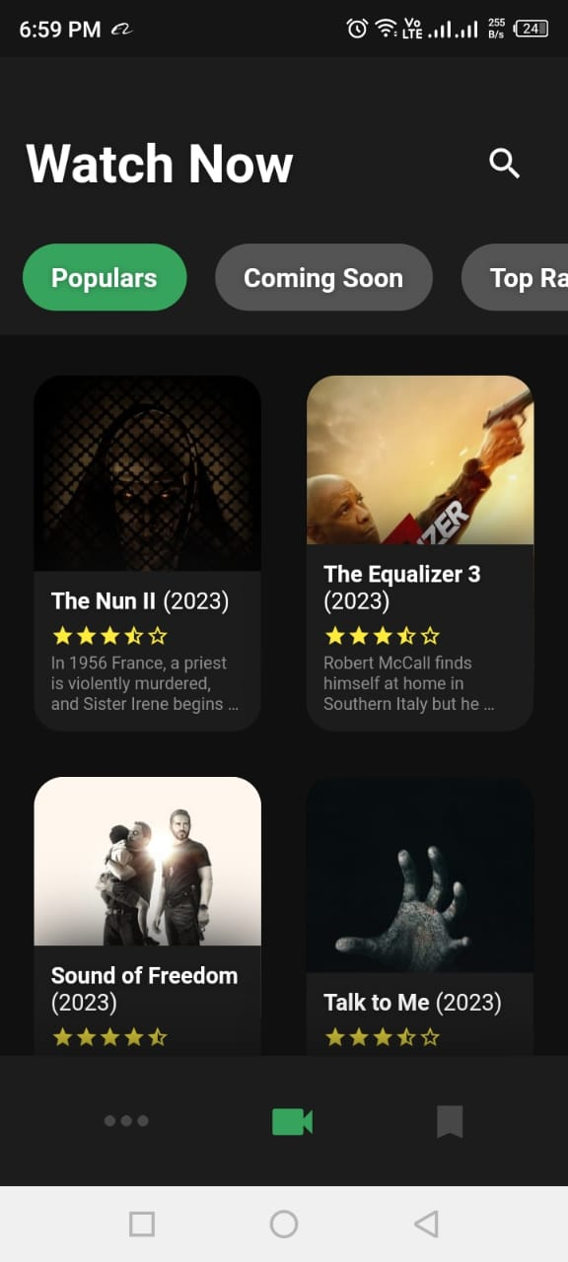

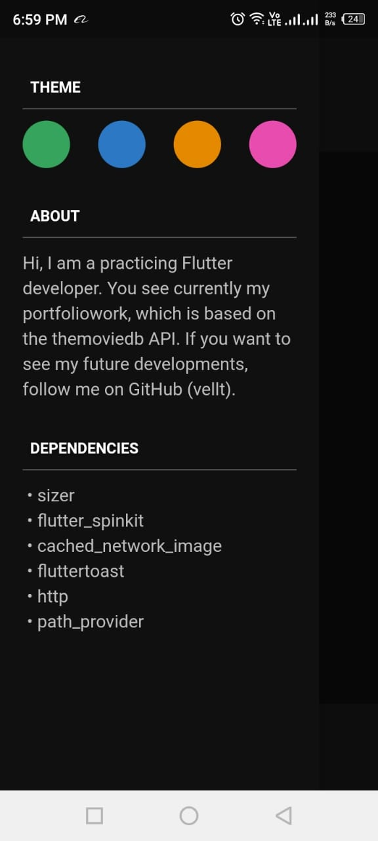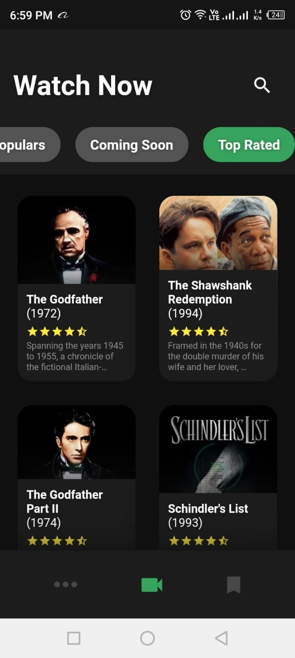

**Project Proposal**

**We propose developing a mobile application " that aims to address the challenge of discovering popular and top-rated movies, as well as upcoming movie releases. The application will provide users with an intuitive and engaging interface to explore the world of movies.**

**Features**

**1. Popular Movies: Display a list of popular movies.**

**2. Upcoming Movies: Show a list of upcoming movie releases.**

**3. Top Rated Movies: Showcase top-rated movies.**

**4. Responsive UI: Ensure a consistent user experience across various platforms and screen sizes.**

**5. Data Storage: Utilize a local database to store movie information for offline access.**

**Technology Stack**

**Framework:Flutter for cross-platform development.**

**State Management: Provider package for optimal state management.**

**Data Storage: SQLite for local data storage.**

**Networking: HTTP package for API requests.**

**Image Caching: Cached Network Image package for efficient image loading.**

**Feedback: FlutterToast for displaying informative messages.**

**Report**

**Real World Problem Identification**

**In today's digital age, there is an abundance of movies being released daily, making it difficult for users to keep track of popular movies, upcoming releases, and top-rated films. Users often struggle to find a centralized platform that provides comprehensive information and recommendations about movies.**

**Proposed Solution**

**The MovieInsight application aims to provide a solution by presenting users with a clean and intuitive interface to explore popular, upcoming, and top-rated movies. The app will fetch data from a movie database and present it to the user in an organized and easily accessible manner. Additionally, the app will allow users to save their favorite movies for future reference.**

**Responsive User Interfaces**

**Screenshots of the MovieInsight app on different screens and platforms will be provided in the final report to showcase the responsiveness and consistency of the UI.**

**### Data Storage**

**We will use SQLite for local data storage due to its lightweight nature and efficiency for handling movie-related data. Storing data locally allows users to access movie information even when offline.**

**Issues and Bugs Encountered and Resolved during Development**

**Detailed information about any encountered issues and bugs, along with the respective resolutions, will be documented in the final report.**

**Conclusion**

**The MovieInsight application aims to address the challenge of movie discovery and provide users with a one-stop solution for exploring popular, upcoming, and top-rated movies. By leveraging cross-platform development and optimal state management techniques, we intend to create an easily maintainable and user-friendly application.**